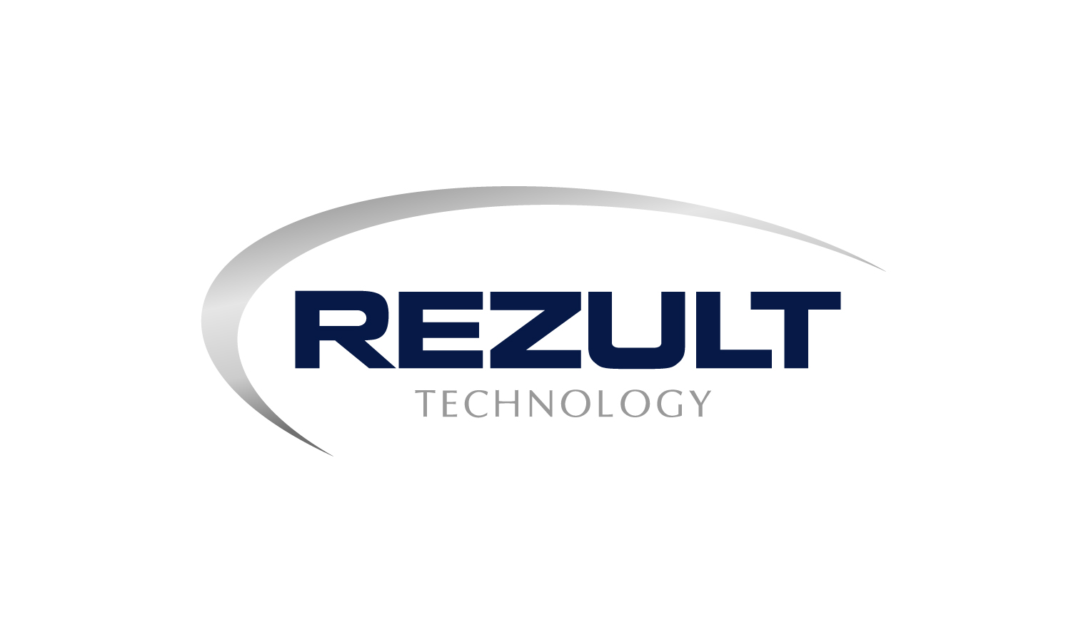
We partner with people who drive technology.

Helpful Advice with a Proven Rezult

Congratulations on your opportunity! You have been selected from numerous candidates to sell yourself to a potential employer. We want to ensure that we provide you with all the tools necessary to be successful in your career transition.

Hiring an employee can be compared to purchasing a product. The number one reason why a consumer does not make a purchase is fear. As money does not grow on trees, we realize that we have to relinquish funds for a product. Hence the million dollar question: IS THE PRODUCT WORTH THE MONEY? As we fear the unknown in purchases, so organizations fear investing their funds in individuals. The purpose of this exercise is to reduce the fear of the prospective employer, thus increasing your chances of obtaining an offer.

Step #1: Get Ready (Preparation)

It has been proven that candidates who are prepared for an interview increase their chances of being hired by over 60%. 60%!!!!!!!!!!!!!!!! That is a big number. If this is an opportunity that you are interested in, it is up to you to be prepared.

Knowing Your Prospective Employer

The first step in preparation is to gain a great understanding of what your prospective employer does and how they make money. If you were making a hiring decision, would you lean toward an individual that knew what your company did or to someone that didn’t take the time or effort to research your organization? There are many ways to research your potential employer and we have provided you with a tool to assist in information gathering. (See Next Attachment)

Do some digging

Remember how excited you were when you heard the words: “Open Book Exam” in school? If you have the answers to the test, you have a better chance of correct answers. We know that you will possibly have an opportunity to get the answers to your employer’s questions before they are asked, but you must be prepared. These smart questions need to be ready well before you shake a hand or say hello. (See Next Attachment).

www.rezulttechnology.com

We partner with people who drive technology.

Step #2: Go Time (The Interview)

The time has come. You now have a chance to convince them why you are worth the money they plan to pay you. The number one way to prove this is by making a good first impression. Studies show that there are numerous ways you can improve your chances of making a good impression.

1. Be Prepared: Discussed earlier in the exercise.

2. Be Early / Not Late: Punctuality is factored in the hiring decision. Since that is the case, show up 10 minutes early and wait. Why risk it?

3. Dress Better & Feel Better: Business dress is a must. Suit / business attire expresses that you are serious about this opportunity. We can assure you that the company is serious about their money.
4. Organization: Bring a portfolio with company information, your references, your listed strengths, and most importantly, your smart questions. If you don’t have a portfolio, buy a legal pad and throw a pen in your pocket.

5. Show Your Personality: Initiate pleasantries. Remember, this person most likely will be working with you everyday. People hire others that they like and feel comfortable around. HOW IS YOUR DAY GOING?

6. Eye to Eye: Generally, looking away is a sign of uncertainty or deception. Remember, the number one reason why people don’t buy is fear.

7. Thank You = Courteous: Always thank the interviewer before the interview starts and after it is finished. They are busy and have many responsibilities other than interviewing.

8. Get the Answers: If given the opportunity to ask questions before the interview starts, do it! The answers to your questions will tell you what they are looking for. Open ended questions allow them to talk and people love to talk. If you listen more than you talk, you just got hired! That is a fact!

9. Relax / Listen / Respond: An interview is not a race. The person who talks the most does not win. An interview should be interactive. Relax, listen to the question, think, and then DIRECTLY respond to the question.

10. Ask For It If from all the information you have, you want the job, ask for it!
www.rezulttechnology.com
We partner with people who drive technology.

Step #3: Aftermath (The Follow Up)

You were prepared and made a positive impression. Your ability to address their fear and discuss your strengths has separated you from the rest. It is time to reassure the interviewer(s) that your impression was not just your ability to interview, but stand for who you are.

Closure: You want answers. Either a yes or no is better than not knowing. Gain a clear understanding of the next step in progressing toward your new career. Simply ask “what is the next step in the interview process?”

Reach Out: First things first. You need to able to communicate. Ask for a business card. This shows your ability to follow up until you get results.

It’s Our Turn: It’s our job to get closure. That is why we work for you. Give us a call as soon as you are finished with the interview. The more information we have the better we will be able to assist in your career transition.

Thank You: Send a follow up email of thanks. This is a must. Remember, the interviewer is very busy and you want to reconfirm your professionalism.

Congratulations! You did your part in the interviewing process. Was it that painful? Our guess is that it wasn’t if you followed our exercise. It is our turn to assure that all your hard work is not wasted. Our partners have many years of experience and we will do everything in our power to assist in your career transition.

Thank you for working with Rezult Technology. We appreciate the opportunity to work with you and best of luck in all of your endeavors.

Sincerely,

Rezult Technology
www.rezulttechnology.com

